

<Name of Software Application>

# **CS 465 Project Software Design Document**

Version 1.0

## Table of Contents

**CS 465 Project Software Design Document** 1

Table of Contents 2

Document Revision History 2

Instructions 2

Executive Summary 3

Design Constraints 3

System Architecture View 3

Component Diagram 3

Sequence Diagram 4

Class Diagram 4

API Endpoints 4

The User Interface 4

## Document Revision History

| Version | Date | Author | Comments |
| --- | --- | --- | --- |
| 1.0 | |  | | --- | | 10/02/2025 |  |  | | --- | |  | | Shekhar Chaudhary | Initial draft for Milestone One submission |

## 

Executive Summary

The Travlr Getaways web application will be built using the **MEAN stack** (MongoDB, Express.js, Angular, and Node.js) to meet the client’s requirements for a scalable and maintainable full stack solution. The system will be composed of two primary user interfaces:

* **Customer-facing Website**: A responsive, public-facing interface that allows users to browse travel packages, search for destinations, view detailed trip information, and manage bookings. This site prioritizes usability, speed, and accessibility across devices.
* **Administrator Single Page Application (SPA)**: An Angular-based admin dashboard that enables staff to manage trip data, update destination details, and monitor customer activity in real-time. The SPA provides rich, interactive functionality with seamless transitions and reduced load times compared to traditional multi-page applications.

By leveraging the MEAN stack, the application will be highly modular, allowing efficient updates and future scalability. The architecture also supports RESTful APIs that ensure smooth communication between the client and server layers.

## Design Constraints

The Travlr Getaways application must be developed under several design constraints:

1. **Technology Stack**: Development is constrained to the MEAN stack, which standardizes the tools and ensures consistency across the front end and back end. This reduces flexibility to use alternative frameworks or databases but ensures better integration.
2. **Performance and Scalability**: The application must support potentially thousands of users simultaneously. This requires careful database indexing, efficient API design, and optimized front-end rendering.
3. **Security**: Since customer information and booking data are sensitive, the application must implement secure authentication, authorization, and data encryption practices. These requirements may add complexity and additional development time.
4. **Time and Scope**: The application must be delivered within the academic project timeframe. This constraint limits the number of features that can be included in the first release, requiring prioritization of core functionalities.

**Implications:** These constraints guide design decisions, ensuring that the application remains technically feasible and aligns with client expectations. However, they also require trade-offs such as focusing on essential features first and leaving advanced functionality for future iterations.

System Architecture View: Component Diagram

The Travlr Getaways web application will follow a layered architecture aligned with the MEAN stack. The main components include:

* **MongoDB (Database Layer)**: Stores trip information, user data, and booking records in a flexible NoSQL document format.
* **Express.js (Server Layer)**: Provides a lightweight back-end framework for defining RESTful API endpoints and handling server logic.
* **Angular (Client Layer)**: Powers the customer-facing website and administrator SPA with dynamic, component-based front-end views.
* **Node.js (Runtime Environment)**: Executes server-side JavaScript and manages communication between the database and client.

**Relationships between components:**

* Angular clients (both customer-facing and admin SPA) send HTTP requests to the Express.js server.
* The Express.js server processes these requests and communicates with MongoDB to retrieve or update data.
* Node.js provides the runtime environment that supports Express.js and manages concurrent client requests.
* RESTful APIs connect the client and server layers, ensuring modular and reusable interactions.

This architecture enables scalability, modularity, and maintainability, ensuring the Travlr Getaways application can evolve alongside client needs.

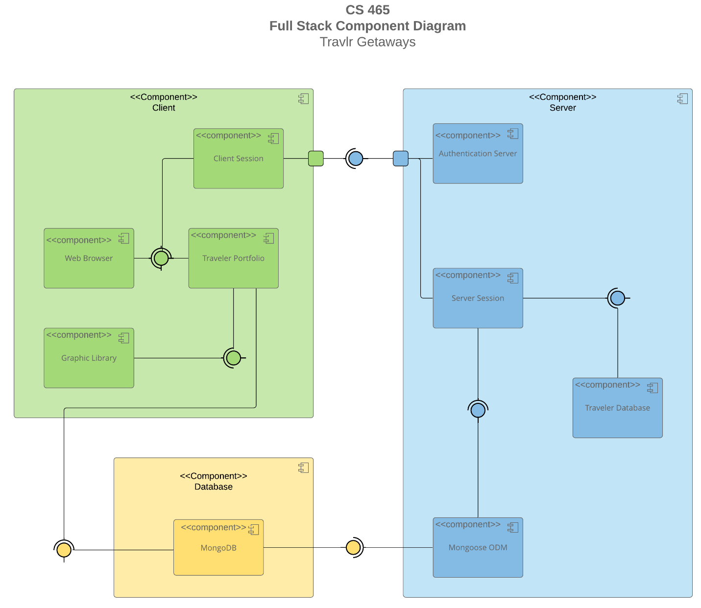

### 1. Sequence Diagram:

Purpose: To illustrate the flow of logic in the Travlr Getaways web application.

Flow Summary:  
The application follows a three-tier architecture using the MEAN stack (MongoDB, Express.js, Angular, Node.js). The diagram should demonstrate how data flows between the client, server, and database through the following key interactions:

1. User Login – Angular client sends a POST /api/auth/login request to Express. Express validates credentials in MongoDB and returns a JWT.  
2. View Trips – Client sends GET /api/trips, server queries MongoDB, returns JSON.  
3. Book Trip – Authenticated user submits POST /api/bookings, server validates and creates a booking.  
4. Admin Update Trip – Admin sends PUT /api/admin/trips/:id, updates MongoDB, and returns confirmation.

Description: The diagram should illustrate request flow between Angular frontend, Express middleware, Node.js runtime, and MongoDB database. Label each layer clearly. Insert the completed sequence diagram image below.

## 2. Class Diagram:

Purpose: To illustrate the JavaScript classes and services that form the foundation of the Travlr Getaways web application.

Classes & Services Overview:  
- User: Represents users with profile and credentials. One user can have many bookings.  
- Trip: Contains trip details such as title, summary, price, dates, and seats.  
- Booking: Links users to trips and stores booking status.  
- AuthService: Handles JWT authentication and session logic.  
- TripService: Manages trip listings and updates.  
- AdminService: Handles admin CRUD operations.

Angular Interfaces (Frontend DTOs):  
interface UserDTO { id: string; email: string; role: 'customer' | 'admin'; }  
interface TripDTO { id: string; title: string; price: number; startDate: string; endDate: string; seats: number; }  
interface BookingDTO { id: string; userId: string; tripId: string; partySize: number; status: 'pending' | 'confirmed' | 'canceled'; }

Description: The class diagram should depict relationships such as one-to-many (User → Booking). Service classes and controllers should be distinct. Insert the class diagram image below.

Classes & Services: Domain entities include User, Trip, and Booking with obvious relationships (a User can have many Bookings; a Booking links one User to one Trip). Service classes encapsulate business logic and API orchestration: AuthService (auth/JWT), TripService (listing, retrieval, update/validation), and AdminService (admin-only create/update/delete). Angular components consume these via HTTP; Express controllers call the services; services access MongoDB models.

Angular side (DTO/Interfaces you render)

export interface UserDTO {

id: string;

email: string;

role: 'customer' | 'admin';

}

export interface TripDTO {

id: string;

title: string;

summary: string;

price: number;

startDate: string; // ISO

endDate: string; // ISO

seats: number;

published: boolean;

images: string[];

availableSeats: number; // computed on server

}

export interface BookingDTO {

id: string;

userId: string;

tripId: string;

partySize: number;

status: 'pending' | 'confirmed' | 'canceled';

}

## 3. API Endpoints

Exposing RESTful endpoints enables the app to participate in a larger ecosystem (web SPA, mobile, future partners). All responses are JSON; secure endpoints require a Bearer JWT in Authorization header.

## Auth

|  |  |  |  |
| --- | --- | --- | --- |
| **Method** | **URL** | **Purpose** | **Notes** |
| POST | /api/auth/login | Sign in with email + password; returns JWT + profile | Body: {email, password}. 200 on success; 401 on invalid creds. |
| GET | /api/auth/me | Get current user profile | Requires JWT; useful for restoring sessions. |
| POST | /api/auth/refresh | Issue a new short-lived access token | Requires refresh token (if implemented). |
| POST | /api/auth/logout | Invalidate refresh token (optional) | Server-side revocation list if implemented. |

## Trips (public)

|  |  |  |  |
| --- | --- | --- | --- |
| **Method** | **URL** | **Purpose** | **Notes** |
| GET | /api/trips | List trips with optional filters | Query params: q, priceMin, priceMax, startAfter, duration, limit, page. |
| GET | /api/trips/:id | Get a single trip by ID | Returns 404 if not found. |

## Bookings (customer)

|  |  |  |  |  |  |  |  |  |  |  |  |  |  |  |  |  |  |  |  |  |
| --- | --- | --- | --- | --- | --- | --- | --- | --- | --- | --- | --- | --- | --- | --- | --- | --- | --- | --- | --- | --- |
| |  |  |  |  | | --- | --- | --- | --- | | **Method** | **URL** | **Purpose** | **Notes** | | POST | /api/bookings | Create a booking for a trip | Body: { tripId, partySize }. Requires JWT (customer). Validates seat availability. | | GET | /api/bookings | List current user’s bookings | Requires JWT (customer). | | GET | /api/bookings/:id | Get a single booking | AuthZ: owner or admin. | | DELETE | /api/bookings/:id | Cancel a booking | Transitions status to canceled; idempotent. | |

## Admin (CRUD on trips)

|  |  |  |  |
| --- | --- | --- | --- |
| **Method** | **URL** | **Purpose** | **Notes** |
| POST | /api/admin/trips | Create a new trip | Body: {title, summary, price, startDate, endDate, seats, images, ...}. Admin JWT required. |
| PUT | /api/admin/trips/:id | Update an existing trip | Partial updates allowed; server validates fields; 409 on stale version if ETag used. |
| PATCH | /api/admin/trips/:id/status | Toggles publish/unpublish | Useful for workflow without editing full document. |
| DELETE | /api/admin/trips/:id | Delete a trip | Soft delete recommended (flag) to preserve booking history. |

| **Method** | **URL** | **Purpose** | **Notes** |
| --- | --- | --- | --- |
| GET | /api/health | Liveness/readiness | Returns {status: "ok", uptime}. No auth. |

**Common Status Codes:** 200 OK, 201 Created, 204 No Content, 400 Bad Request (validation), 401 Unauthorized, 403 Forbidden, 404 Not Found, 409 Conflict (optimistic concurrency), 422 Unprocessable Entity (semantic validation), 500 Internal Server Error.

## The User Interface

1. **Unique Trip (Customer UI) — “Everest Base Camp Explorer”**
   * Card/list view with hero image, title, summary, price, dates, and “View Details” button.
   * Detail page shows full description, seat availability, gallery, and “Book Now.”
   * Evidence it’s unique (e.g., a badge “Added by Shekhar” or a distinct slug).
2. **Admin – Edit Trip Screen**
   * Reactive form (Angular) with fields: title, summary, price, startDate, endDate, seats, images, published.
   * Inline validation messages (e.g., “Price must be greater than 0”, “Start date must be before end date”).
   * “Save” (PUT), “Cancel” (router back), and form pristine/dirty indicators.
3. **Admin – Update Confirmation**
   * Success toast/snackbar (“Trip updated”), and the updated trip visible in the admin list.
   * Optimistic UI refresh or a reload of the list/detail showing the new values.

Angular Frontend Architecture (Admin SPA)

The Angular application in this project functions as a **Single Page Application (SPA)** dedicated to the administrative (backend) interface of Travlr Getaways. Its responsibilities include:

* Providing a dynamic, responsive user interface for creating, editing, and deleting trip offerings
* Handling client-side routing so that navigation within the admin interface does not trigger full page reloads
* Communicating with the backend REST API (Node/Express) through HTTP (GET, POST, PUT, DELETE) to fetch and update trip, booking, and user data
* Managing authentication state (e.g. storing/verifying JWT) to protect admin-only routes and features
* Using TypeScript-built services, components, and modules to structure the frontend code in a modular, maintainable fashion
* Mapping backend DTOs to frontend models (interfaces / classes) so that data received from the API can be used cleanly and consistently in Angular components

**Typical Angular project structure** (in this project) includes:

* components/ — UI components (e.g. trip list, edit form, login)
* services/ — Angular services for API calls (e.g. TripService, AuthService)
* models/ — TypeScript interfaces or classes for domain objects (User, Trip, Booking)
* app-routing.module.ts — Client-side route definitions
* assets/, environments/, etc. — Supporting files

Because this is an SPA, once the site loads, the UI updates dynamically based on user interactions and data responses, without requiring full page refreshes. This results in a smoother and more responsive admin experience.

Thank you!!!